You are given a table, BST, containing two columns: N and P, where N represents the value of a node in Binary Tree, and P is the current parent of N.

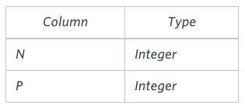

Write a query to find the node type of Binary Tree ordered by the value of the node. Output one of the following for each node:

* Root: If node is the root node.
* Leaf: If node is leaf node.
* Inner: If node is neither root nor leaf node.

Sample Input

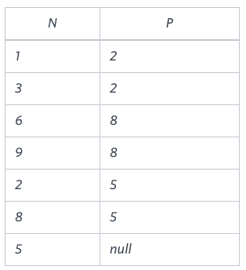

Sample Output

1 Leaf

2 Inner

3 Leaf

5 Root

6 Leaf

8 Inner

9 Leaf

**Explanation**

The Binary Tree below illustrates the sample:

